External Python

Git Link:-
https://github.com/Nazil1712/PyQt_Calc/commits/main

Aim:-
Extend the given calculator code using concepts of OOP and software engineering in Python programming with the following buttons.
Data Size converter (Bits to Bytes(vice versa), Bytes to Kilobytes(vice versa), Kilobytes to Megabytes(vice versa))
The Existing code is in https://github.com/hemantnyadav/calc_using_python
Make proper git commits and document all commits.

Commits:-
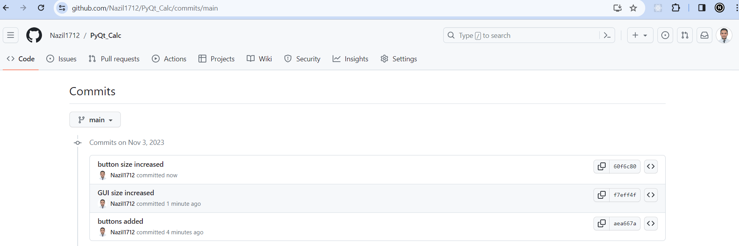

Output:-
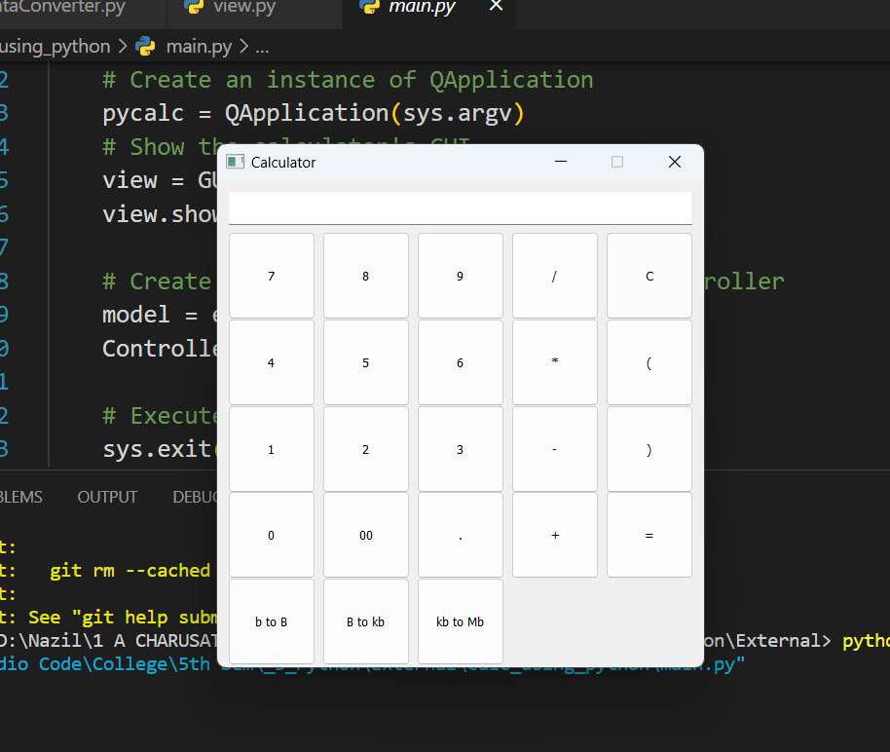

Steps:-
- I have just added the 3 buttons in view.py and applied position.
- Then I increased the size of overall Calculator GUI.
- Then I increased the size of buttons individually.

